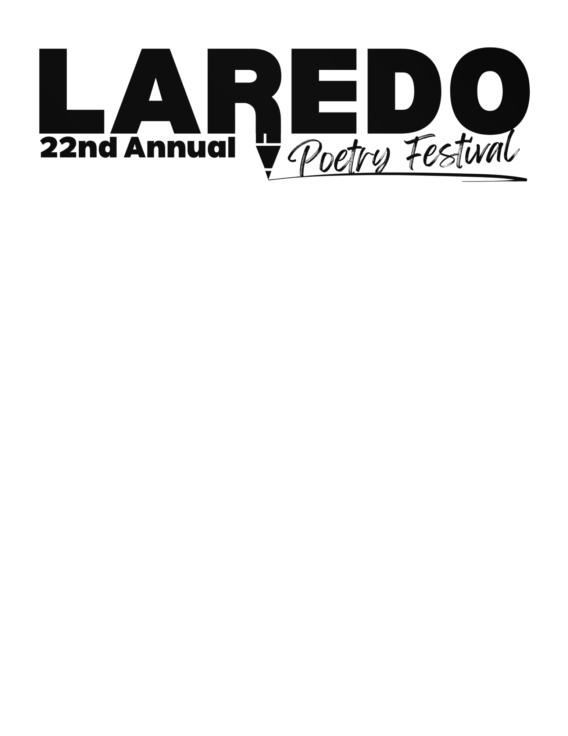

Applicant Entry Form
(Please Copy as Needed)

First & Last Name: ___________________________________________________________________
Grade: ______________________________________________________________________________
Home Mailing Address: ________________________________________________________________
_____________________________________________________________________________________
Applicant’s E-mail: ____________________________________________________________________
Applicant’s Phone (if 18 or over):_________________________________________________________
Parent or Guardian Name (if under 18):___________________________________________________
Parent or Guardian Phone: ( ) _______________________________________________________
School Name: _________________________________________________________________________
Teacher's Name: ______________________________________________________________________
School Address: _______________________________________________________________________
______________________________________________________________________________________
School Phone: ( ) ___________________________________________________________________
Teacher’s E-mail: ______________________________________________________________________
Brief Description of Poem: _______________________________________________________________
_______________________________________________________________________________________
The work I am submitting is my own original creation, not copied from others, produced by anyone else, or generated by artificial intelligence.

Applicant Signature ________________________________________________ Date ____________

Mail entries with form attached to:
Laredo Public Library
1120 E. Calton Road
Laredo TX 78041
(956) 795-2400
DEADLINE FOR SUBMITTING POEMS: FEBRUARY 7, 2025

