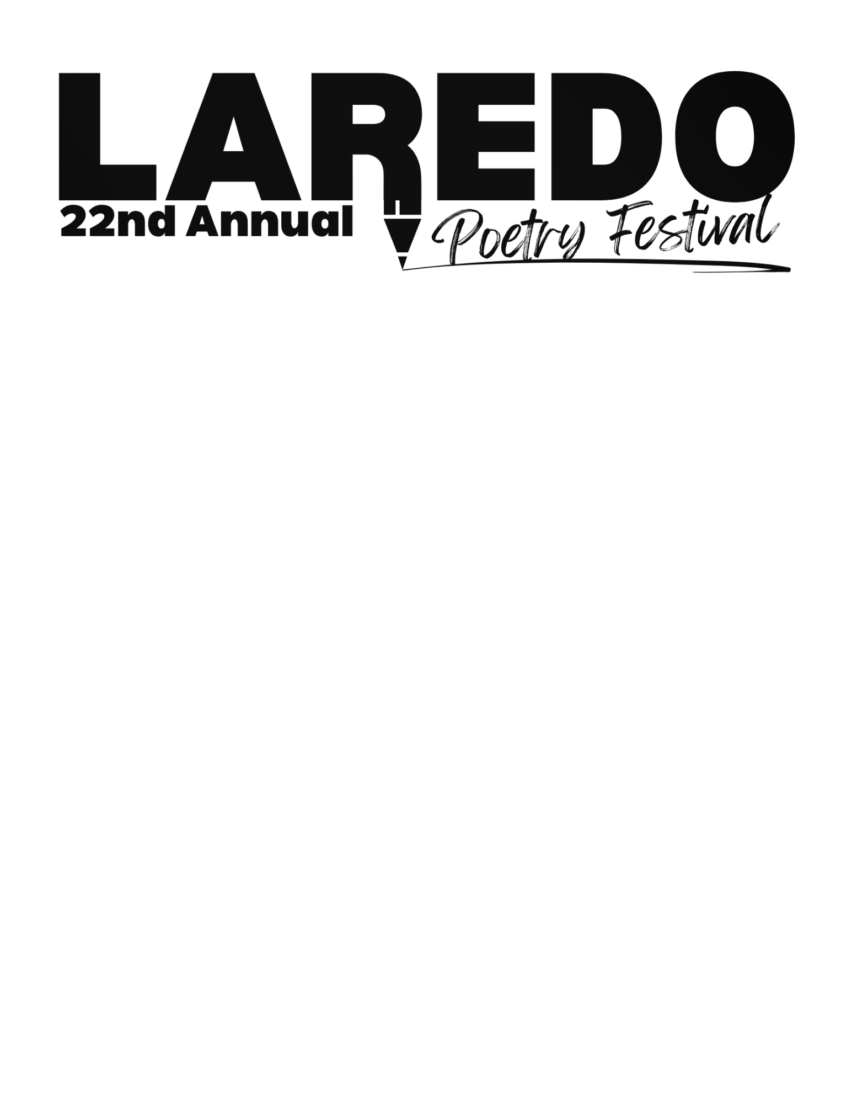

### Date: April 26, 2025

**Time: 1:00 – 3:00 p.m.**

**Location: Multipurpose Room, Laredo Public Library** (1120 E. Calton Road)

**Subject:**

* **Dreams and Aspirations** are the central theme for the 22nd Annual Poetry Festival.

# Rules of Participation:

* A poem in its entirety **must be an original work** by the person entering the contest; plagiarized poems will be disqualified.
* Poems may be written in any standard format.
* Text should be typed. Font size 12
* Poems should be no longer than 2 pages, double-spaced.
* Submit 2 copies of your poem, 1 with no name on it.
* Only one entry per person will be accepted; no co-authors of a poem will be accepted.
* The poem will be accepted via the website and in person.
* The application form needs to be filled out.
* The parents or legal guardian will fill out the Release Form for students under 18.

## Language:

* English or Spanish.
* Mix English and Spanish

## Participants:

* Students from LISD, UISD, private schools, and homeschooling.
* Adults 18 and over.

## Method:

* Divide all contestants by age and grade level.
* **The deadline for submitting poems is by 6:00 p.m. at the Laredo Public Library (Main branch).**
* 3-7 judges in each group will review all poems received & select the top 3 winners and 1-3 honorable mention recipients.
* The top 3 winners in each group will read their poems and receive prizes and gift bags**.**
* Honorable Mentions will receive gift bags and the option to read their poems.
* All participants will receive certificates of participation.

**Results:**

* Publish the winners’ poems.
* Continue the Poetry Festival every year as a local educational activity.

### Sponsors:

### Laredo College Laredo Independent School District Texas A & M International University

### United Independent School District Laredo Public Libraries

**DEADLINE FOR SUBMITTING POEMS IS FEBURARY 7th**