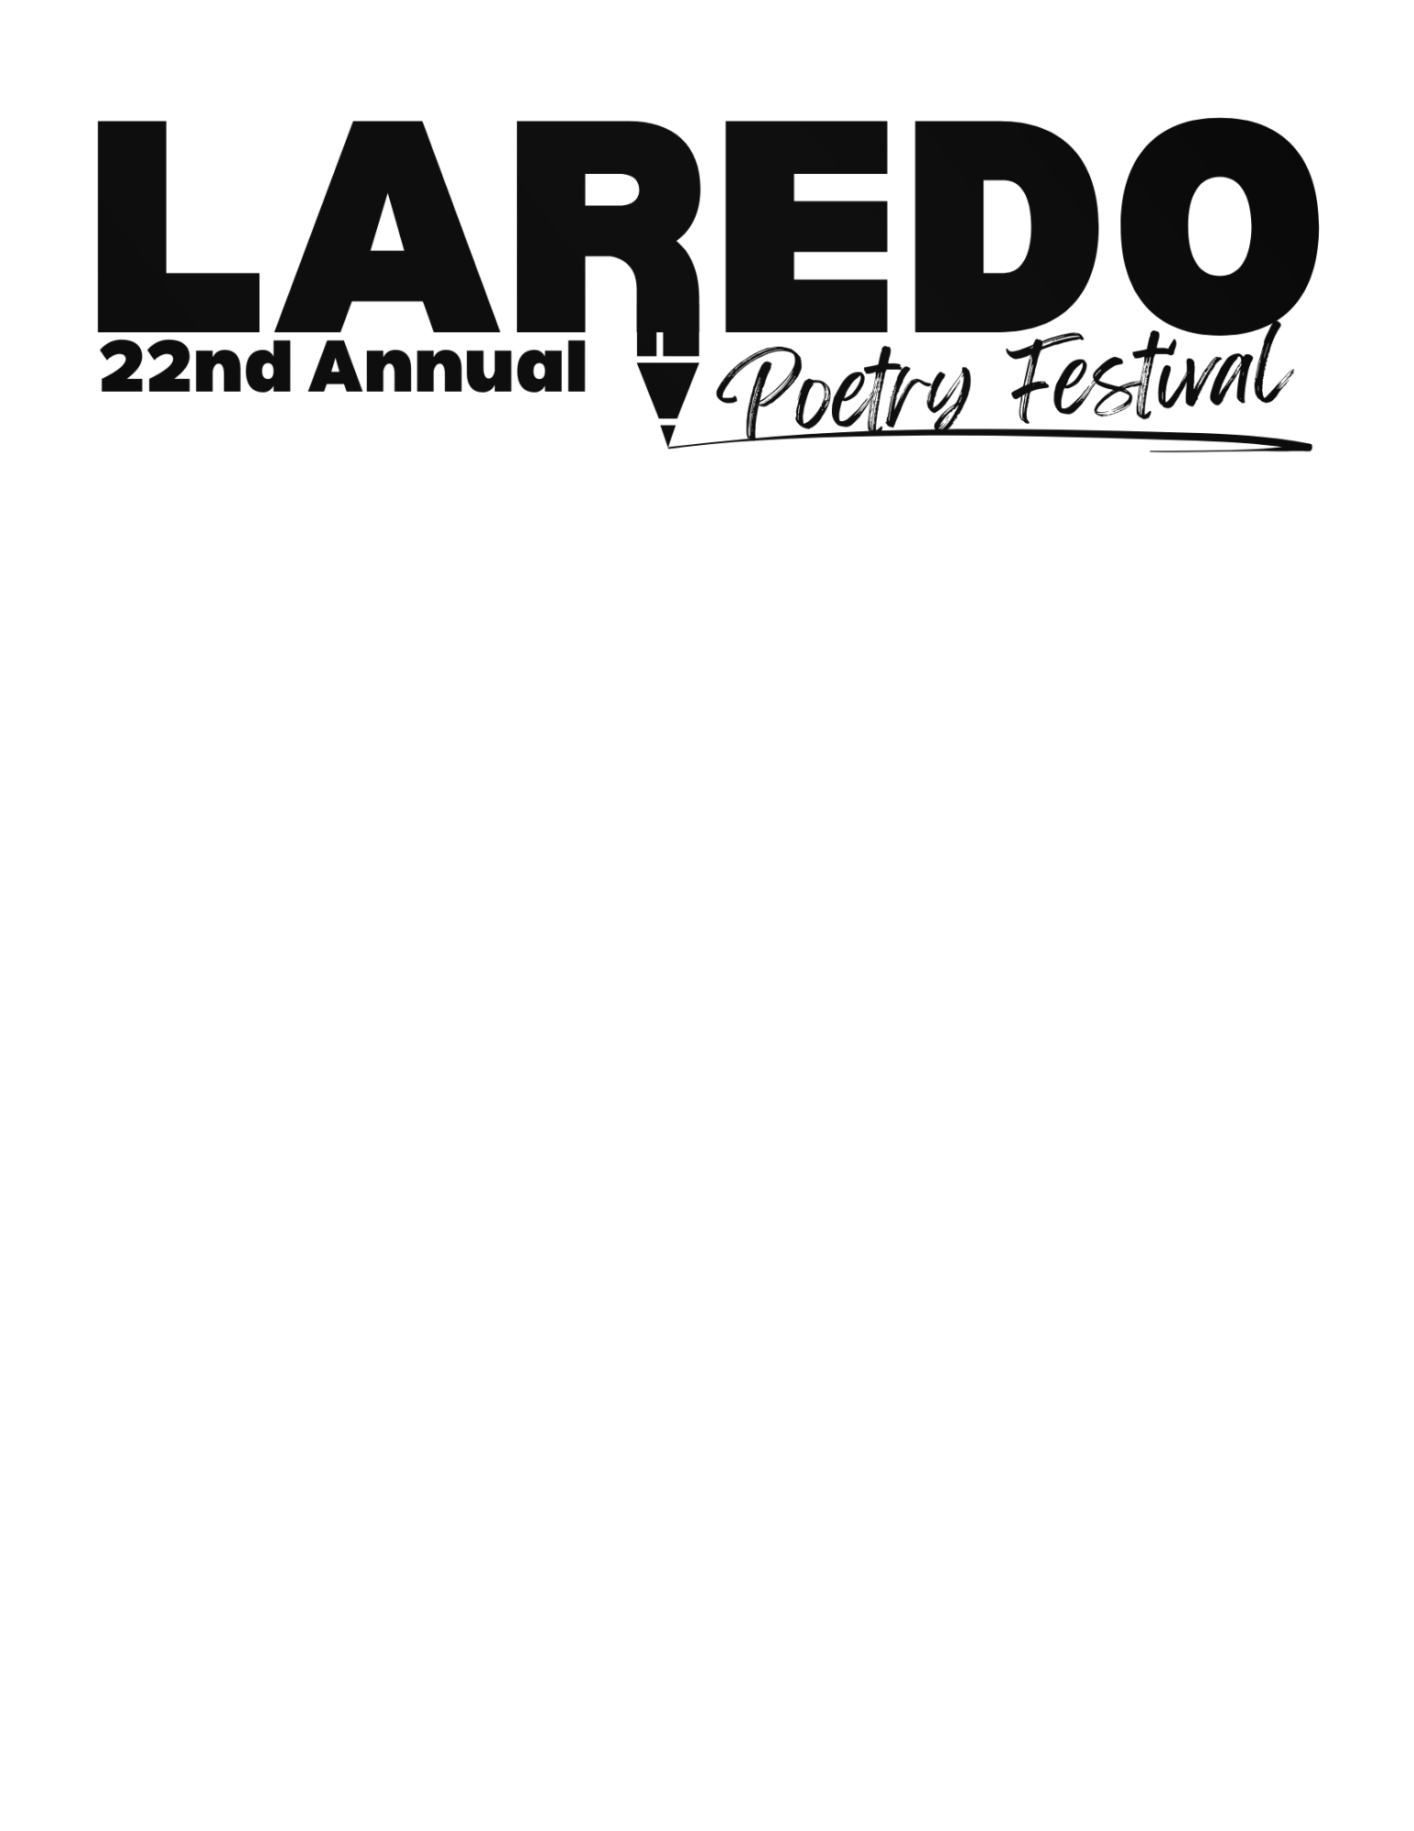

RELEASE

I , the parent or guardian of
, a minor child, do hereby give my permission for this child to participate in the 22nd Annual Laredo Poetry Festival and to publish this child’s poem if selected. I understand that all reasonable precautions will be taken to provide a safe program experience for this child and that in consideration thereof for myself and for this minor child, and for the heirs, executors, and administrators and assigns of myself and this minor child, I hereby release the City of Laredo, and the Laredo Public Library and their employees and volunteers, from any liability or causes of indemnity and hold harmless the City of Laredo and the Laredo Public Library and their employees and volunteers from any claim arising against them on behalf of this minor child in this program.
Parent’s or Guardian’s Signature |  | Date

By registering your child, you give the Festival sponsors permission to reproduce and publicize pictures and your child’s poems as long as it is not a confidential matter.

